H&M: The Retail-Clothing Giant
David Beckham, Freja Beha, Beyoncé, Gisele Bündchen, Georgia May Jagger, Miranda Kerr, Madonna, Vanessa Paradis, Katy Perry, Lana Del Rey, Rihanna, and Anja Rubik represent just a partial list of well-known people around the world who have worked with H&M (do you recognize all of them?). But, let’s move on from the name-dropping to Hennes & Mauritz, or H&Mas it is more commonly known. H&M is a Swedish multinational retail-clothing giant known for its fashion clothing for women, men, teenagers, and children. H&M has effectively used superstar celebrities like David Beckham, Beyoncé, and Gisele Bündchen for years to carry their advertising message worldwide. Behind the scenes, H&M’s global supply chains are equally well orchestrated and are as high powered as its advertising campaigns.
H&M Hennes & Mauritz AB is now the full name of the company (it started simply as “Hennes” in 1947 in a small Swedish town called Västerås). The idea for the company emerged when, in 1946, Erling Persson, the company’s founder, came up with the idea of offering fashionable clothing at relatively low prices while he was on a business trip to the United States. At that time, Persson decided to focus on women’s clothing only, and “Hennes,” which means “her” or “hers” in Swedish, was started. A couple of decades later, in 1968, Hennes acquired the building and inventory of hunting equipment retailer Mauritz Widforss. A supply of men’s clothing was also part of the inventory. This resulted in menswear being included in the company’s collection—and gave birth to Hennes & Maurits (H&M). H&M now has some Page 5133,200 stores in 54 countries and approximately 116,000 employees. It is the second-largest clothing retailer in the world after Spain-based Inditex (parent company of ZARA) and ahead of U.S.-based Gap Inc.
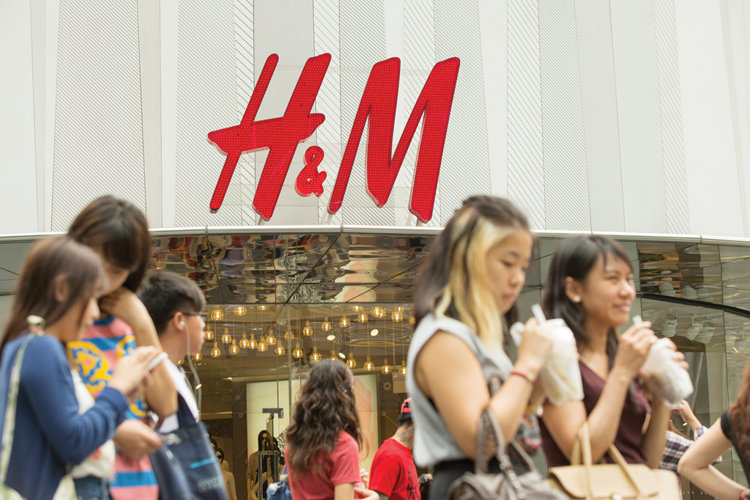Pedestrians walk past an H&M store in Singapore. © Charles Pertwee/Bloomberg/Getty Images
H&M comprises six different brands, although the H&M brand is the most recognizable worldwide. The other brands are COS, Monki, Weekday, Cheap Monday, and & Other Stories. H&M designs sustainable fashion for all people at relatively modest prices and sells its products in 54 countries and online in an additional 10 markets. COS explores the concept of style over fashion and sells its products in stores and online in 38 countries. Monki is promoted as a fashion experience and is offered in 30 markets in stores and online. Weekday is a jeans-focused fashion destination with sales in 25 markets. Cheap Monday combines “influences from street fashion and subculture with a catwalk vibe” and is offered in some 20 markets. The last brand, called “& Other Stories,” was launched in 2013 and focuses on personal expression and styling, with availability in 17 markets. The collection of these brands, driven by the H&M collection and its footprint in 64 countries, presents a unique global supply chain challenge for the company.
The collections of clothing are created by a team of 160 in-house designers and 100 pattern makers. The design and pattern team is large and diverse, representing different age groups and nationalities. H&M's design process is about “striking the right balance between fashion, quality and the best price . . . and it always involves sustainability awareness.” H&M does not own its own factories, but instead works with around 900 independent suppliers to implement the team’s designs into reality. These independent suppliers are mostly located in Europe and Asia. They manufacture all of H&M’s products, and they also generally source fabrics and other components needed to create the fashion statements we have come to know from the H&Mbrands. Some 80 people in the H&M organization are dedicated to constantly audit the working conditions at the factories of suppliers, including safety and quality testing and ensuring that chemicals requirements are met.
Within the global supply chain infrastructure, one key aspect of H&M is the ordering of each product. Specifically, ordering each product at the optimal moment is an important part of H&M achieving the right balance among price, cycle time, and quality. To realize the effectiveness needed to ultimately sell fashion-oriented clothing at affordable prices, H&M works closely with long-term partners and invests significant resources into the sustainability of the work needed in its supply chains. In these areas, the company strives to promote lasting improvements in working conditions and environmental impact throughout the footprint that it makes worldwide. Through its 900 suppliers, H&M is connected to some 1,900 factories and about 1.6 million workers.
Sources: H&M website, http://hm.com, accessed April 12, 2014; L. Siegle, “Is H&M The New Home of Ethical Fashion?,” The Observer, April 7, 2012; G. Petro, “The Future of Fashion Retailing—the H&M Approach,” Forbes, November 5, 2012; K. Stock, “H&M’s New Store Blitz Moves Faster Than Its Digital Expansion,” Bloomberg Businessweek, March 17, 2014; M. Kerppola, R. Moody, L. Zheng, and A. Liu, “H&M’s Global Supply Chain Management Sustainability: Factories and Fast Fashion,” GlobaLens, a division of the William Davidson Institute at the University of Michigan, February 8, 2014.

